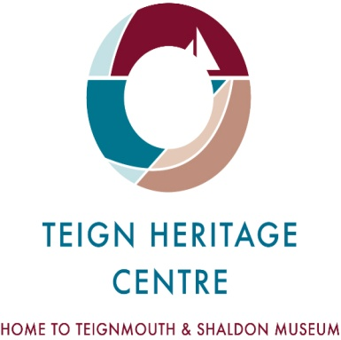 Welcome to your history!

In 2011 a striking building for public use opened in Teignmouth: the renovated previous museum, and adjacent
to it the iconic new – and award winning - Teign Heritage Centre, constructed with funding from the Heritage Lottery Fund, CABE SeaChange, the Foyle Foundation and many others - including local residents. The THC now offers a modern interpretation of our local history with fascinating exhibits, as well as being a much-needed community facility, and as we have discovered, a much-used one – from meetings to dance classes, etc.

We invite you to join Teign Heritage!

Members receive unlimited entry, a bi-annual Journal with articles on local and maritime history, etc.; lectures, events and special summer exhibitions. Another perk is free access for enquires to the Archives! The THC is fully accessible: lift, toilets and hearing induction loops, and we have a delightful roof-top terrace area. The multi-purpose Teign Room is available for meetings, recitals, small conferences, etc., and has audio-visual aids [screen, projector, microphones and recording and playback facilities].

All this for just £18 per person. Our year runs from 1 January to 31 December

If you are a UK taxpayer please sign and date the Gift Aid section below, we can receive an extra 25%. Just complete the following application clearly and either post or leave it for the Membership Secretary at 29 French Street, Teignmouth, TQ14 8ST.

Title: ______ First name or initial[s]:_____________ Surname:________________________

Full home address: ________________________________________________________________

_______________________________________________ Post code: _________________

Telephone number: ____________________________Email _______________________@______________

Signed: _____________________________ Date:________________ 202______

You can pay by cheque, cash or card for £ ___________ Cheque payable to Teign Heritage Ltd

Gift Aid Declaration:

I am a UK taxpayer and understand that if I pay less income tax and/or capital gains tax in the current [or any subsequent] tax year than the amount of Gift Aid claimed on all my donations it is my responsibility to pay any difference. I understand that [a] other taxes such as VAT and Council Tax do not qualify and [b] the charity will reclaim 25p of tax on every £1 that I give and [c] that I must notify the charity if I wish to cancel this declaration, or if I change my name or home address, or if I no longer pay sufficient tax [income and/or capital gains] and that [d[ if I am liable for higher rates of tax I can claim further tax relief when completing my annual HMRC Self Assessment tax return.

Signed: _________________________ Date: _____________ 202_____

Teign Heritage Centre, 29 French Street, Teignmouth, Devon, TQ14 8ST 01626 777041
www.teignheritage.org.uk info@teignheritage.org Teign Heritage is a company limited by guarantee, No.5874265, and a charity, No.1116204

